**Use of master and slave in Jenkins**

* Jenkins checks the Git repository at periodic intervals for any changes made in the source code.
* Each builds requires a different testing environment which is not possible for a single Jenkins server. In order to perform testing in different environments Jenkins uses various Slaves as shown in the diagram.
* Jenkins Master requests these Slaves to perform testing and to generate test reports.

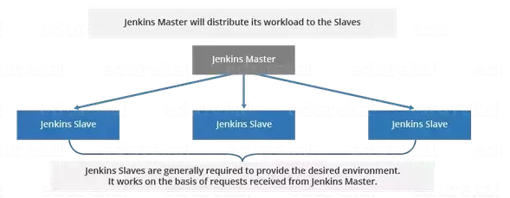

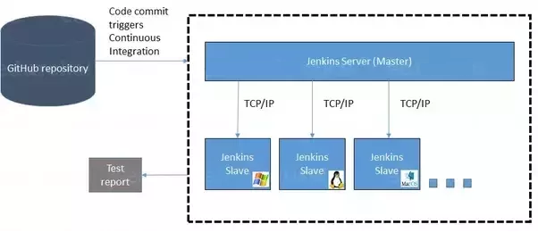

**Jenkins distributed Architecture**

* Jenkins uses a Master Slave architecture to manage the distributed builds
* The Master and slave communicate through Tcp/IP Protocol.

**Jenkins Master:** Your main Jenkins server is the Master.

* Scheduling build jobs.
* Dispatching builds to the slaves for the actual execution.
* Monitor the slaves (possibly taking them online and offline as required).
* Recording and presenting the build results.
* A Master instance of Jenkins can also execute build jobs directly.

**Jenkins Slave:** A Slave is a Java executable that runs on a remote machine

* It hears requests from the Jenkins Master instance.
* Slaves can run on a variety of operating systems.
* The job of a Slave is to do as they are told to, which involves executing build jobs dispatched by the Master.

**How to configure Jenkins Master to Slaves/Nodes/Clients**

**Create 3 instances in AWS which ever you want**

**I am taking 3 ubuntu instances i.e**

1. **Jenkins_Master 🡪Private Ip: 172.31.95.197**
2. **Jenkins_Slave1**
3. **Jenkins_Slave2**

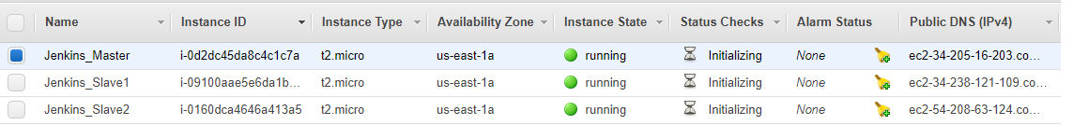

**Install Jenkins on Master -🡪 Open the Terminal of Jenkins_Master**

* **switch user to root 🡪 sudo su -**
* **switch user to Jenkins 🡪 sudo su – jenkins**
* **now generate sshkey in Master**

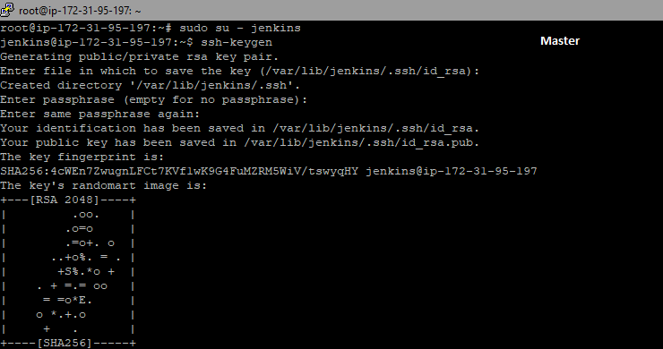



* **copy the public key and paste into the Jenkins_Slave1 and Jenkins_Slave2**

**Now open Jenkins_Slave1 terminal**

**vi .ssh/authorized_keys 🡪 esc I, esc o 🡪 paste the master public key into this**

**and close esc :wq!**

**Check is correctly pasted or not 🡪 cat .ssh/authorized_keys**

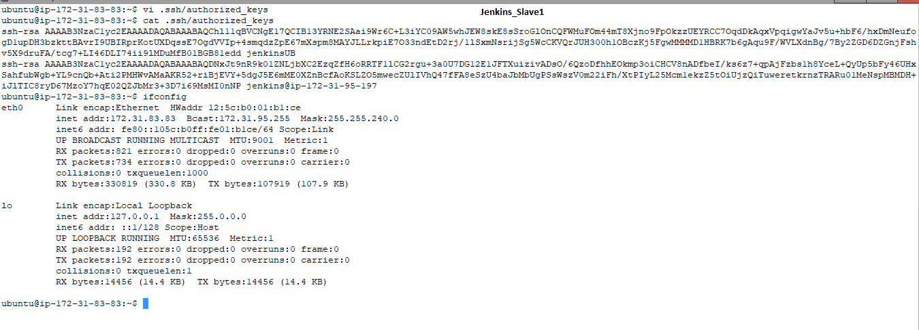

**Copy the private ip of Jenkins_Slave1 to master for the communication purpose**

**ssh ubuntu@172.31.83.83**

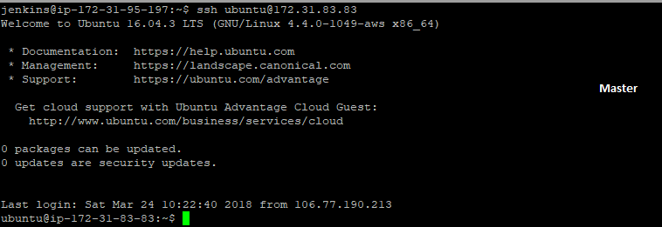

**Exit form that to master**

* **Jenkins is written in Java so if want to connect the Jenkins master java is perquisite so install java in Jenkins_slave1 and also update apt Repo**

**sudo apt-get update**

**sudo apt-get install openjdk-8-jdk**

**after that create one directory name as Jenkins**

**mkdir Jenkins 🡪 ls🡪 cd Jenkins 🡪pwd**

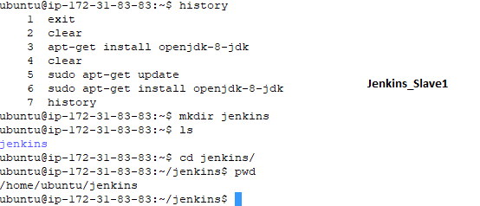

**Now go to Jenkins Dashboard 🡪** [**http://54.89.229.86:8080/**](http://54.89.229.86:8080/)

**Manage Jenkins🡪 Manage Nodes🡪 **

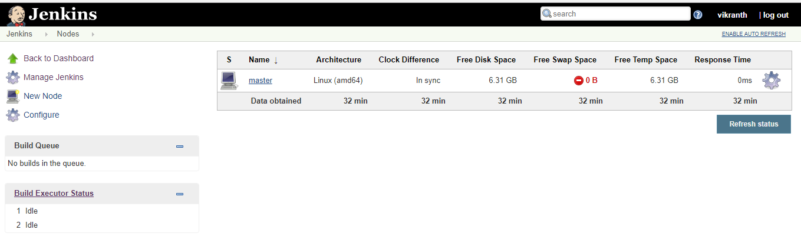

**Click on New Node🡪 give the node Name and select Permanent🡪 ok**

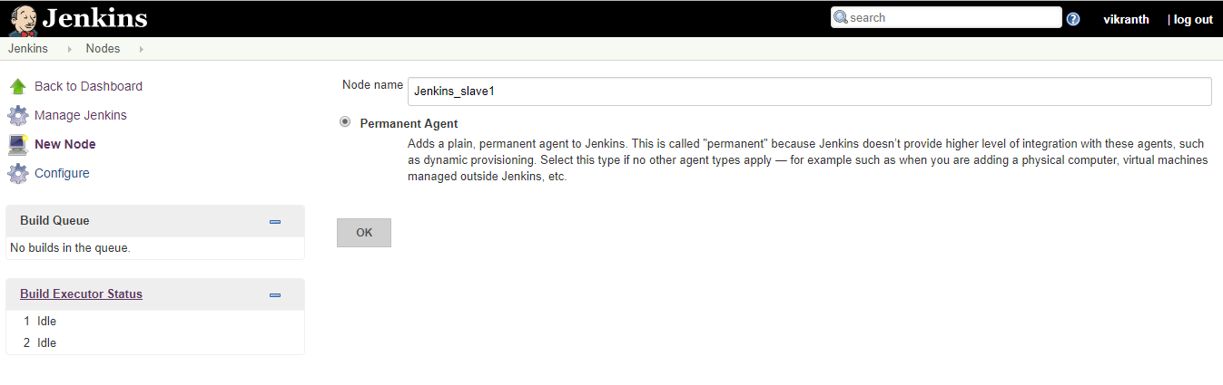

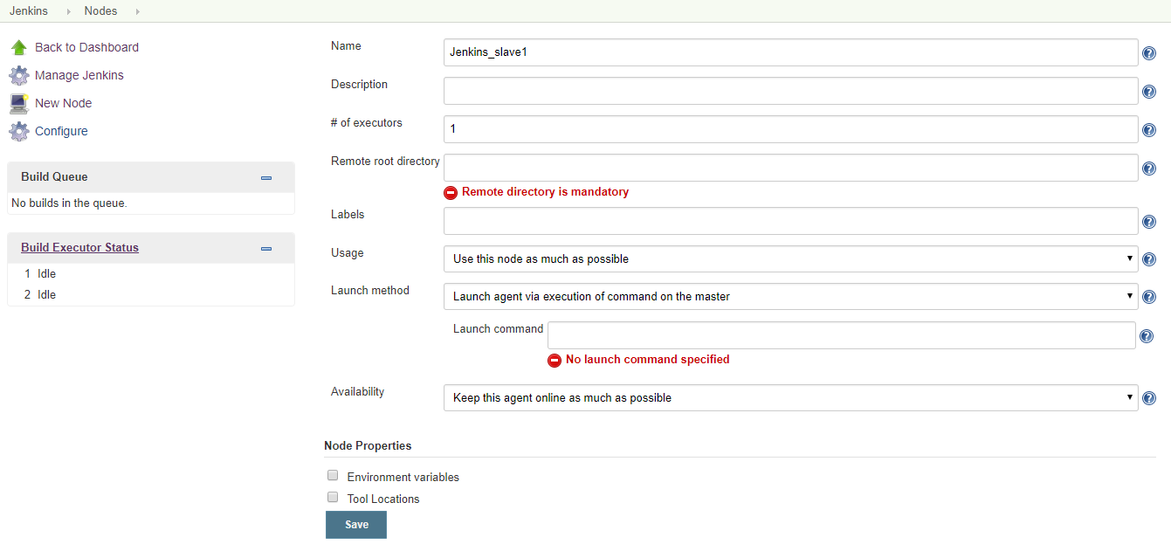

**Under Remote root Directory-🡪 give slave1 home Directory path i.e**

**/home/ubuntu/Jenkins**

**Give the labels as 🡪 linux whatever it is**

**Launch method select the 🡪Launch ssh agents via SSH**

**Host 🡪 give the private ip of slave1 🡪** **172.31.83.83**

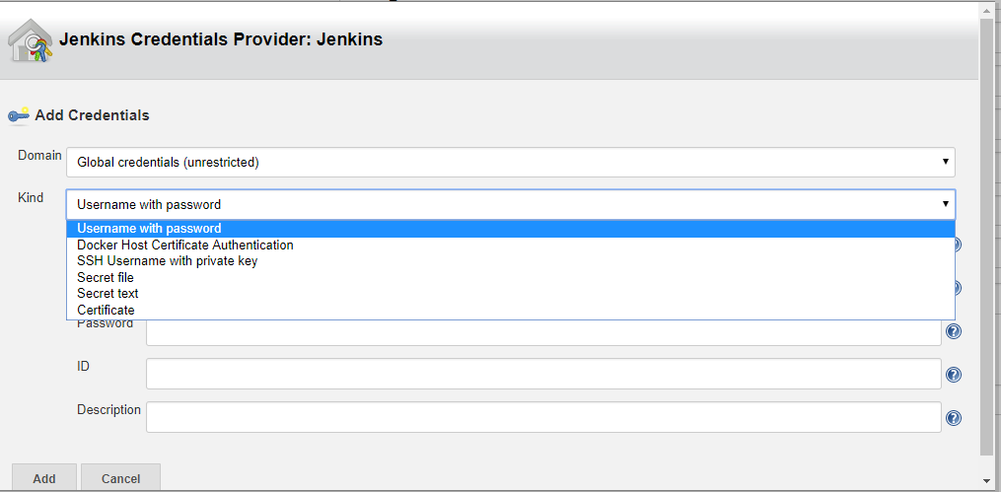

**Kind🡪 username with password**

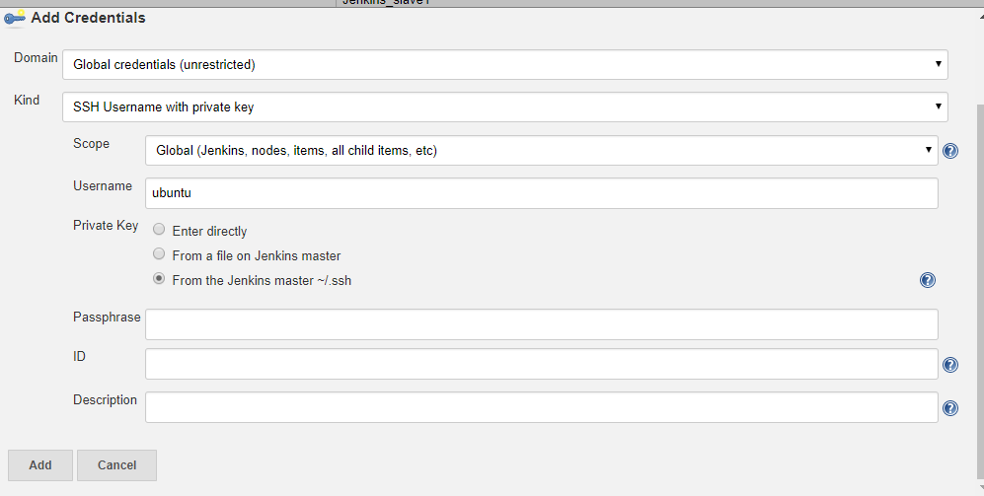

**User name as 🡪ubuntu**

**Private key🡪 🡪 add**

**Under credentials 🡪 take the user name**

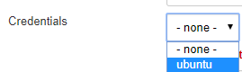 **click on ok**

**Now click on Jenkins_Slave1🡪**

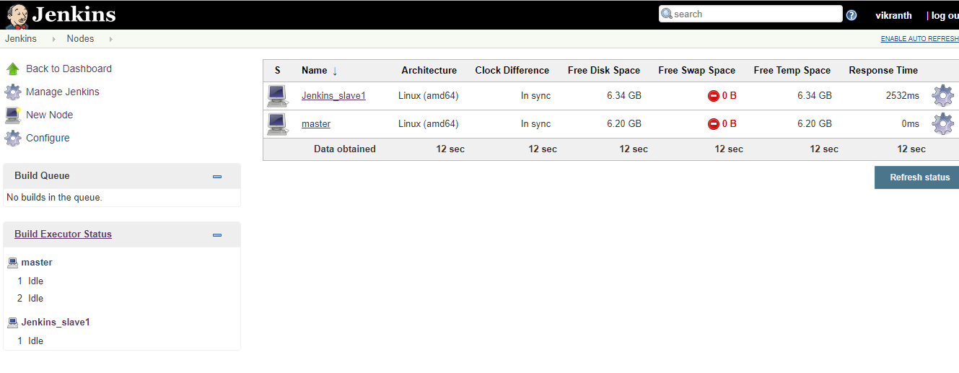

**Now Jenkins_Slave1 added to master successfully**

**Similarly you can add many number of slaves to ur Master**

**Now connect slave2 to master**

**Steps:**

* **Copy the ssh public key and paste into the Slave2**
* **Check the communication between master and slave2**
* **Install the java in slave2**
* **Create the directory as Jenkins in slave**
* **on Jenkins dashboard🡪**

**Manage nodes🡪**

**add node🡪**

**give remote directory as slave home directory 🡪 /home/ubuntu/jenkins**

**labels name -- linux🡪**

**Take launch method as 🡪 Launch slave agents via SSH**

**Host 🡪 give the slave2 private ip**

**Click on add 🡪 Jenkins🡪 kind🡪 SSH Username with private key**

**User Name 🡪 ubuntu**

**Private key 🡪 select From the Jenkins Master ~/.ssh 🡪 add**

**Credentials 🡪**

**take user name 🡪 ubuntu**

**save  
click on launch the slave2**

**----------------------------------------------------------------------------------------------------**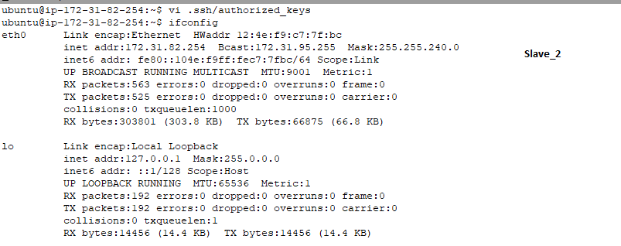

**sudo apt-get update**

**sudo apt-get install openjdk-8-jdk**

**mkdir Jenkins 🡪 /home/ubuntu/Jenkins**

**now go to Jenkins dashboard 🡪 Manage Jenkins🡪 Manage Nodes🡪 New Node**

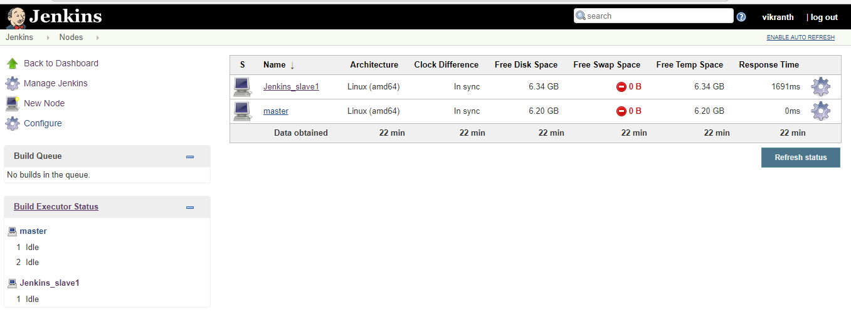

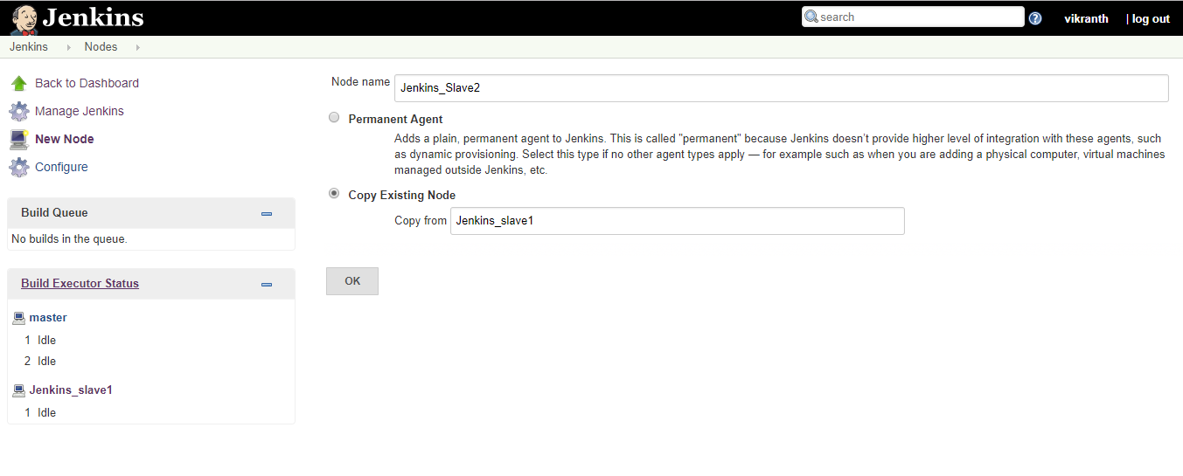

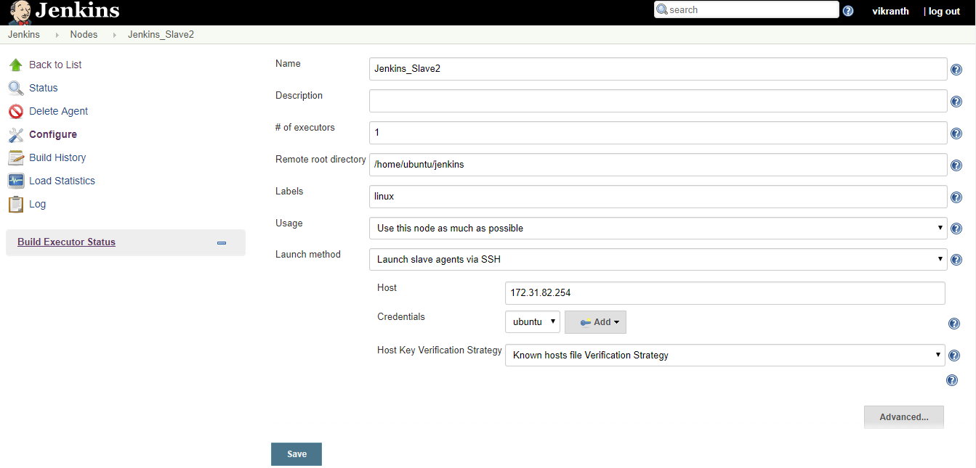

**Give the all details and save**

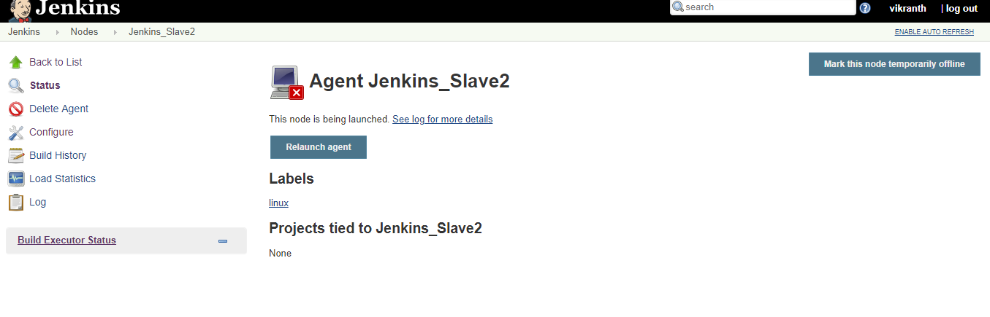

**Click on Relaunch agent**

**And go to nodes🡪**

